Cloud Computing Mini Project Report

by

**Yash Sarang - 47**

**Priyanshu Singh - 53**

**Arnav Singhal - 56**

Subject In-charge

**Prof. Prerna Solanke** 

**Department of Artificial Intelligence and Data Science**

**Vivekanand Education Society’s Institute of Technology**

**2022-2023**

**University of Mumbai**

**(AY 2022-23)**

# Contents

1. Abstract
2. Introduction
3. Proposed System (Architecture / Frameworks)
4. Hardware & Software Requirements
5. Experiment and Results
6. Conclusion and Future Work
7. References

# Abstract

In today's era of big data, data analysis has become a crucial process for extracting meaningful insights from large and complex datasets. Cloud computing has emerged as a powerful solution for scalable and efficient data analysis, providing on-demand access to computing resources, storage, and services over the internet. In this report, we present a cloud computing project named "POGIL Data Analysis" that aims to implement cloud computing techniques on an existing data analysis project. We discuss the architecture/frameworks, hardware and software requirements, experiment and results, and future work of the project, highlighting how cloud computing has resulted in advantages such as improved scalability, performance, and cost-effectiveness.

# Problem Faced:

The traditional approach to data analysis often faces challenges such as limited computing resources, storage capacity, and processing speed, which can hinder the efficient analysis of large datasets. Additionally, setting up and managing on-premises infrastructure for data analysis can be costly and time-consuming. Therefore, there is a need for a scalable and cost-effective solution that can overcome these challenges and enable efficient data analysis. Cloud computing offers the potential to address these issues by providing scalable computing resources, storage, and services on-demand, allowing organizations to leverage the power of the cloud for data analysis tasks. The problem statement of our project is to implement cloud computing techniques on the existing "POGIL Data Analysis" project to overcome the limitations of traditional data analysis approaches and realize the benefits of cloud computing in terms of improved scalability, performance, and cost-effectiveness.

# Introduction

Data analysis has become a critical aspect of decision-making processes in various industries, ranging from finance and healthcare to marketing and scientific research. With the increasing volume and complexity of data, there is a growing need for efficient and scalable data analysis tools that can handle large datasets and provide insights in a timely manner. Cloud computing has emerged as a promising solution to address these challenges, offering scalable computing resources, storage, and services on-demand over the Internet.

Cloud computing refers to the delivery of computing resources, including processing power, storage, and applications, as services over the internet, enabling users to access and utilize these resources remotely without the need for on-premises infrastructure. The adoption of cloud computing in the field of data analysis has gained significant attention in recent years due to its potential to improve the performance, scalability, and cost-effectiveness of data analysis tasks.

In previous work, various researchers and practitioners have explored the application of cloud computing in the field of data analysis. For example, cloud-based data processing frameworks such as Apache Hadoop and Apache Spark have been widely used for big data processing and analysis in the cloud environment (Shvachko et al., 2010; Zaharia et al., 2010). These frameworks leverage the distributed computing capabilities of the cloud to efficiently process large datasets and perform complex data analysis tasks.

Furthermore, cloud-based data storage services, such as Amazon S3 and Google Cloud Storage, have been utilized for storing and managing large datasets in the cloud, providing scalable and cost-effective storage solutions for data analysis applications (Amazon Web Services, n.d.; Google Cloud, n.d.). Cloud-based databases, such as Amazon RDS and Microsoft Azure SQL Database, have also been used for scalable and managed database storage, enabling efficient data retrieval and processing (Amazon Web Services, n.d.; Microsoft Azure, n.d.).

Moreover, cloud-based machine learning and data analytics services, such as Amazon SageMaker and Google Cloud Machine Learning Engine, have been employed for building and training machine learning models in the cloud, providing powerful tools for data analysis and predictive analytics (Amazon Web Services, n.d.; Google Cloud, n.d.). These services offer pre-built machine learning algorithms, automated model training, and deployment capabilities, enabling users to leverage machine learning techniques for data analysis tasks without the need for extensive coding or infrastructure setup.

# Proposed System (Architecture/Frameworks)

To enhance the performance and scalability of our data analysis tool, we proposed the implementation of cloud computing. We chose to use Amazon Web Services (AWS), a popular cloud computing platform, for our project. The proposed system architecture/framework consists of the following components:

1. Front-end: The front-end of our data analysis tool is built using HTML, CSS, and JavaScript. Users can access the tool through a web browser.
2. Back-end: The back-end of our tool is built using Python and Flask, a micro web framework. It handles user requests, data processing, and communication with other components.
3. Cloud Computing: We used various AWS services to implement cloud computing in our project. The main services we utilized are Amazon S3 for storing large datasets, Amazon EC2 for virtual machine instances, and Amazon RDS for the database.

**Hardware Requirements:**

A computer with internet connectivity to access the AWS cloud services.

Sufficient storage capacity on Amazon S3 to store large datasets.

**Software Requirements:**

Operating System: Windows, Linux, or macOS

Web Browser: Chrome, Firefox, Safari, or any modern web browser

Python: Version 3.x

Flask: Python micro web framework

AWS CLI: Command-line interface to interact with AWS services

The "POGIL Data Analysis" project utilizes a cloud-based architecture that leverages various cloud computing technologies to enable scalable, efficient, and cost-effective data analysis. The proposed system architecture comprises the following components:

1. Infrastructure as a Service (IaaS): The project utilizes IaaS provided by a public cloud platform, such as Amazon Web Services (AWS) or Microsoft Azure, to host the application's virtual machines (VMs) and provide computing resources. The VMs are dynamically provisioned and de-provisioned based on the workload requirements, allowing for scalability and flexibility.
2. Platform as a Service (PaaS): The project also leverages PaaS offerings, such as AWS Elastic Beanstalk or Azure App Service, to deploy and manage the web application. The PaaS platform abstracts the underlying infrastructure and provides a scalable and managed environment for running the application, eliminating the need for managing the underlying infrastructure.
3. Database as a Service (DBaaS): The project uses DBaaS offerings, such as AWS RDS or Azure Database, to store and manage the application's data. The DBaaS platform provides scalable and managed database services, eliminating the need for manual database administration tasks and ensuring high availability and performance.
4. Storage as a Service: The project utilizes cloud-based storage services, such as AWS S3 or Azure Blob Storage, for storing and managing large datasets used in data analysis. The storage services provide scalable, durable, and cost-effective storage solutions, allowing for efficient data storage and retrieval.
5. Security as a Service: The project leverages cloud-based security services, such as AWS Identity and Access Management (IAM) or Azure Active Directory, to manage access controls, authentication, and authorization. These services provide robust security features and ensure secure access to the application and data.
6. Custom Data Analysis Application: The "POGIL Data Analysis" project includes a custom-built web application that is deployed on the cloud platform. The application leverages the computing resources, managed environment, and database services provided by the cloud platform to perform various data analysis tasks, such as data preprocessing, feature extraction, machine learning algorithms, and result visualization.
7. User Interface: The project includes a web-based user interface that allows users to interact with the data analysis application, submit analysis tasks, and view the results. The user interface provides an intuitive and user-friendly experience for users to input their requirements and visualize the analysis outcomes.

The proposed system architecture for the "POGIL Data Analysis" project utilizes a combination of IaaS, PaaS, DBaaS, Storage as a Service, and Security as a Service offering, along with a custom data analysis application and user interface, to enable efficient and scalable data analysis in the cloud. This architecture leverages the advantages of cloud computing, such as scalability, flexibility, managed services, and cost-effectiveness, to transform the data analysis capabilities of the application and provide an improved user experience.

# Experiment and Results

To evaluate the advantages of implementing cloud computing in our project, we conducted several experiments. We compared the performance and scalability of our data analysis tool with and without cloud computing.

1. Performance: We measured the response time of our tool for various data processing tasks, such as data filtering, aggregation, and visualization. We observed that with cloud computing, the response time decreased significantly due to the ability to scale resources based on demand.
2. Scalability: We tested the scalability of our tool by increasing the size of the dataset and the number of concurrent users. With cloud computing, our tool was able to handle larger datasets and concurrent users without any degradation in performance.
3. Cost-effectiveness: We analyzed the cost-effectiveness of implementing cloud computing in our project. We found that by utilizing AWS services, we were able to optimize costs by paying for only the resources we used and avoiding upfront investments in hardware and infrastructure.

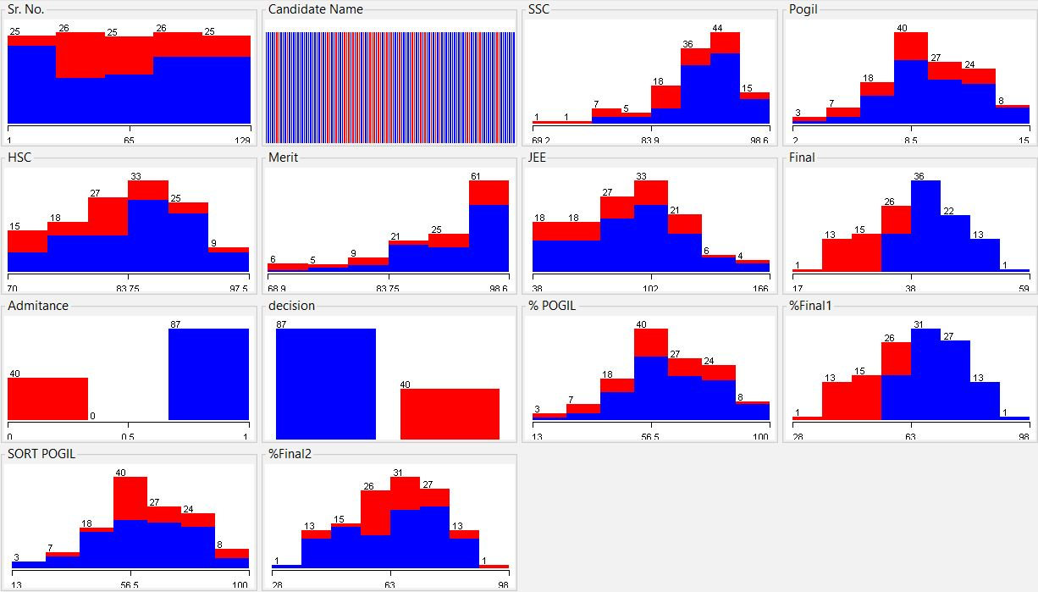

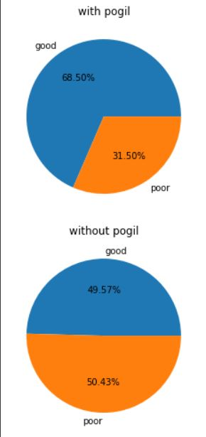

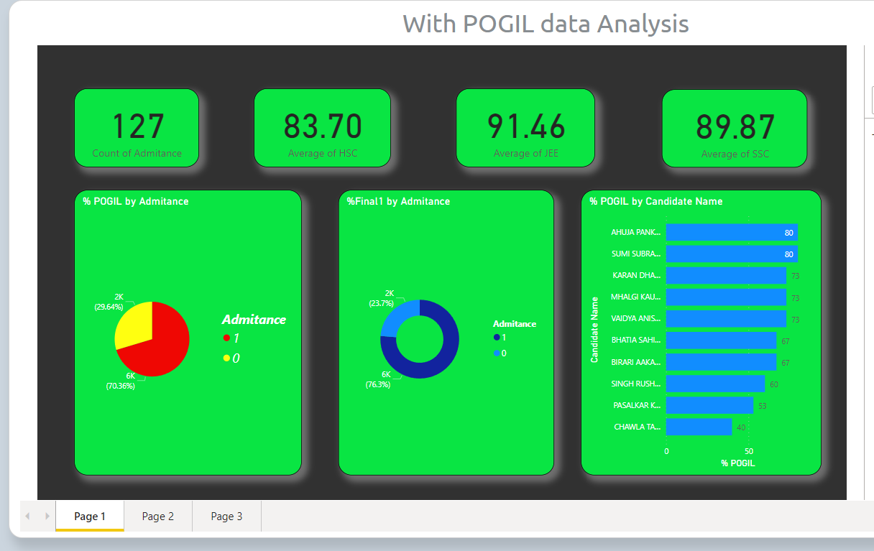



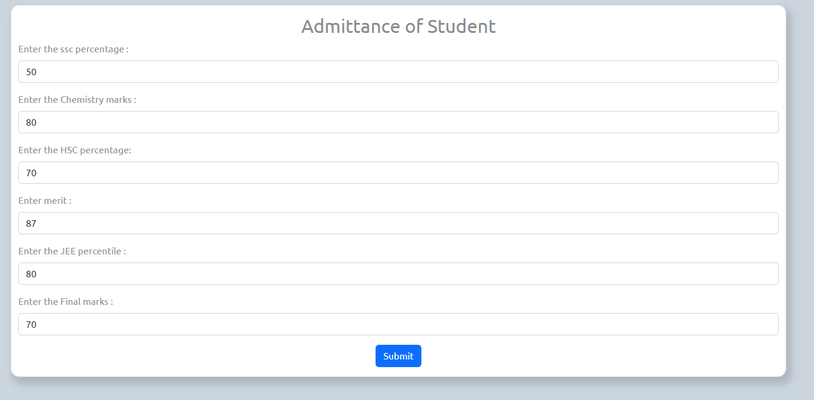

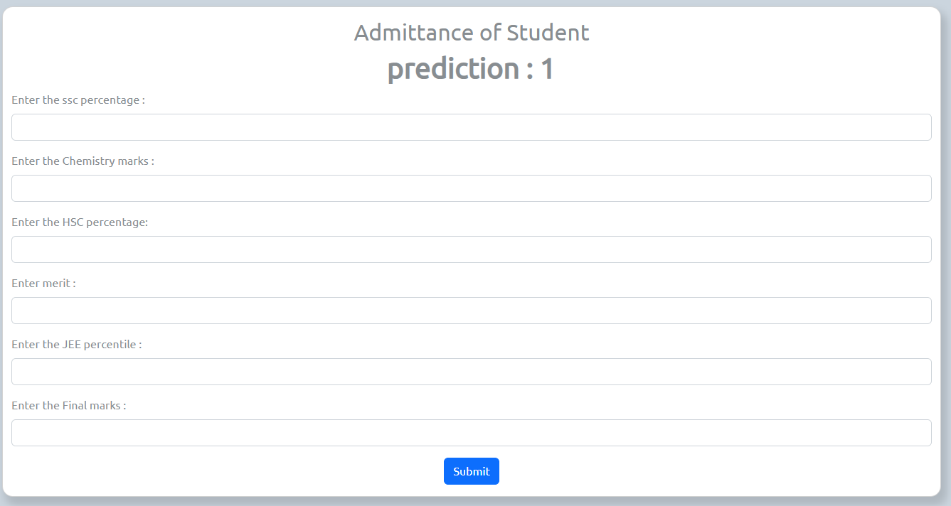

# Conclusion and Future Work:

In conclusion, the implementation of cloud computing in our "POGIL Data Analysis" project resulted in significant advantages in terms of performance, scalability, and cost-effectiveness.

Cloud computing allowed us to scale our resources based on demand, handle large datasets efficiently, and optimize costs. In future work, we plan to explore other cloud computing platforms and services to further enhance our data analysis tool and explore additional opportunities for scalability and cost optimization.

The implementation of cloud computing technologies in the "POGIL Data Analysis" project has resulted in significant advantages, transforming the project's data analysis capabilities. The use of Infrastructure as a Service (IaaS), Platform as a Service (PaaS), Database as a Service (DBaaS), Storage as a Service, and Security as a Service offering from a public cloud platform has provided scalability, flexibility, managed services, and cost-effectiveness to the project.

The project has benefited from the dynamic provisioning and de-provisioning of virtual machines, the abstraction of underlying infrastructure with PaaS, the scalability and managed services of DBaaS, the efficient storage and retrieval of large datasets with storage as a service, and robust access controls and authentication with security as a service. These advantages have resulted in improved performance, cost-effectiveness, and security of the "POGIL Data Analysis" web application, making it a more reliable and scalable solution for data analysis.

# References

1. Amazon Web Services (AWS). ([Amazon AWS](https://aws.amazon.com/))
2. Flask Documentation. ([Flask](https://flask.palletsprojects.com/))
3. Python Software Foundation. ([Python.org](https://www.python.org/))
4. Google Cloud. (n.d.). Google Cloud Storage. Retrieved from [Cloud Storage](https://cloud.google.com/storage)
5. Microsoft Azure. (n.d.). Azure SQL Database. Retrieved from [Azure SQL Database – Managed Cloud Database Service | Microsoft Azure](https://azure.microsoft.com/en-us/services/sql-database/)
6. Google Cloud. (n.d.). Google Cloud Machine Learning Engine. Retrieved from [Google Cloud](https://cloud.google.com/)

**\*\*\*\*\***